**MODALLA PRANITH REDDY**

**2420030158**

**LAB 6**

**Configuration of Network address translation in Cisco packet tracer and verify the configuration**

**Step 1: Launch Cisco Packet Tracer**

**Open Cisco Packet Tracer from your desktop or applications list.**

**Step 2: Create the Network Topology**

**Add Devices**

* **Routers: 2 (Router0, Router1)**
* **Switches: 2 (Switch0, Switch1)**
* **PCs: 2 (PC0, PC1)**

**Connections**

* **PC0 → Switch0 → Router0 (Fa0/0) using Copper Straight-Through**
* **PC1 → Switch1 → Router1 (Fa0/0) using Copper Straight-Through**
* **Router0 Serial2/0 ↔ Router1 Serial2/0 using Serial DCE/DTE**

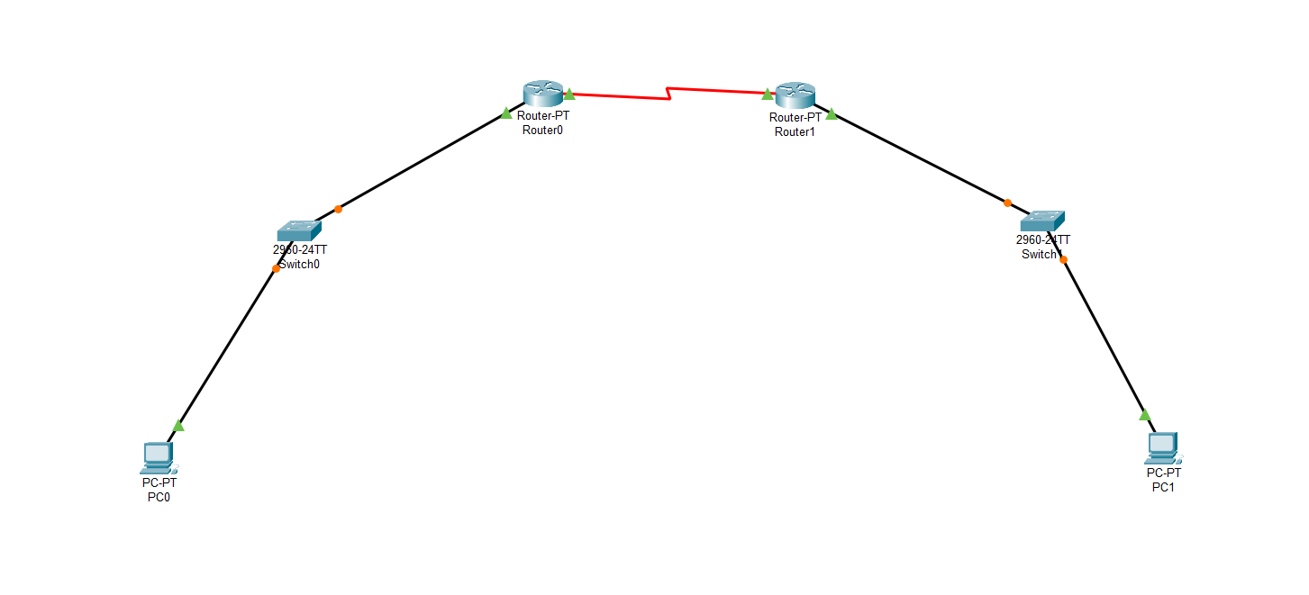

Step 3: Assign IP Addressing

| **Device** | **Interface** | **IP Address** | **Subnet Mask** | **Remark** |
| --- | --- | --- | --- | --- |
| **PC0** | NIC | 10.10.10.2 | 255.255.255.0 | Inside local (LAN A) |
| **Router0** | Fa0/0 | 10.10.10.1 | 255.255.255.0 | Inside interface |
| **Router0** | S2/0 | 192.162.10.1 | 255.255.255.252 | Serial link |
| **Router1** | S2/0 | 192.162.10.2 | 255.255.255.252 | Serial link |
| **Router1** | Fa0/0 | 20.20.2.1 | 255.255.255.0 | Inside interface |
| **PC1** | NIC | 20.20.2.2 | 255.255.255.0 | Inside local (LAN B) |

**Step 4: NAT Public IP Mappings (Outside Global)**

* **PC0 (10.10.10.2) ↔ 50.50.50.2**
* **PC1 (20.20.2.2) ↔ 60.60.60.2**

**Step 5: Configure Router0 (CLI)**

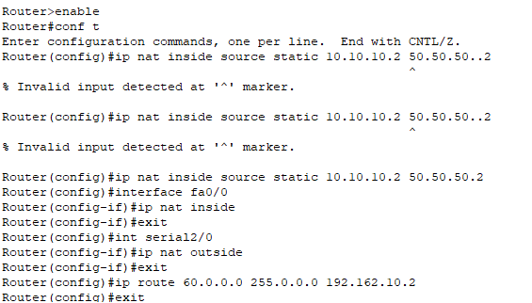

**Step 6: Configure Router1 (CLI)**

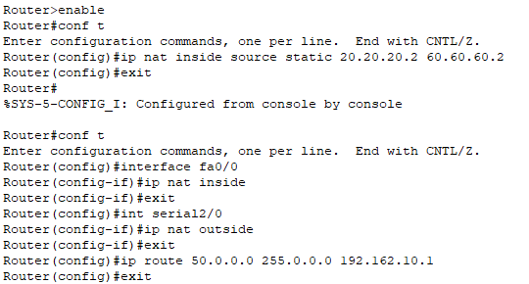

**Step 7: Configure PCs**

**PC0 (LAN A):**

* **IP Address:** 10.10.10.2
* **Subnet Mask:** 255.255.255.0
* **Default Gateway:** 10.10.10.1

**PC1 (LAN B):**

* **IP Address:** 20.20.2.2
* **Subnet Mask:** 255.255.255.0
* **Default Gateway:** 20.20.2.1

**Step 8: Verify the Configuration**

1. Open **Command Prompt** on **PC0** and **PC1**.
2. From **PC0 → PC1**
3. From **PC1 → PC0**

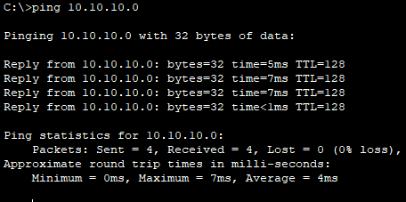

**Step-9 :** Click on Simulation to run it.